**Project Initialization and Planning Phase**

|  |  |
| --- | --- |
| Date | 13 July2024 |
| Team ID | 740679 |
| Project Name | Exploratory Analysis of Rain Fall Data in India for Agriculture |
| Maximum Marks | 3 Marks |

**Define Problem Statements (Farmer Problem Statement Template):**

Indian agriculture is highly dependent on the monsoon season, and the variability of rainfall poses significant challenges. Unpredictable rainfall patterns can lead to severe consequences such as droughts, floods, and crop failure. Existing forecasting models often lack the precision needed at a local level, making it difficult for farmers to rely on these predictions for their day-to-day agricultural activities.

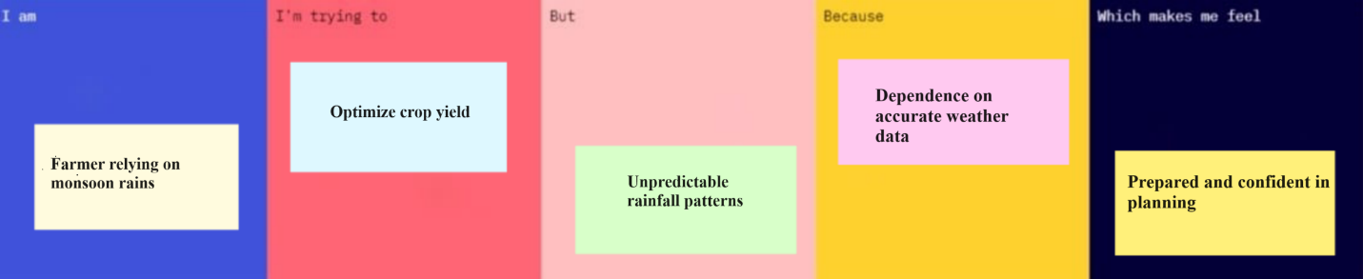

|  |  |  |  |  |  |
| --- | --- | --- | --- | --- | --- |
| **Problem**  **Statement**  **(PS)** | **I am**  **(Customer)** | **I’m trying to** | **But** | **Because** | **Which makes me feel** |
| PS-1 | An Indian farmer relying on rain-fed agriculture. | Plan my agricultural activities and optimize crop yield. | The rainfall patterns are highly unpredictable and unreliable. | There is a lack of accurate and localized rainfall prediction models. | Anxious about crop failure and financial instability.. |